FBRA -

Functionality

The document that contains cleared items cannot be reversed directly. You need to first reset cleared items. During clearing open items the system always creates a clearing document. This document contains the information about cleared items, clearing date etc.

Scenario
A few documents have been cleared against each other. Before they can be re-cleared to the correct documents, they must be reset from the clearing of wrong documents.

Requirements
A previously posted clearing document.

Menu Path | Accounting → Financial Accounting → General Ledger → Document → FBRA - Reset Cleared Items
Transaction Code | FBRA

1. Double click on FBRA - Reset Cleared Items

Reset Cleared Items

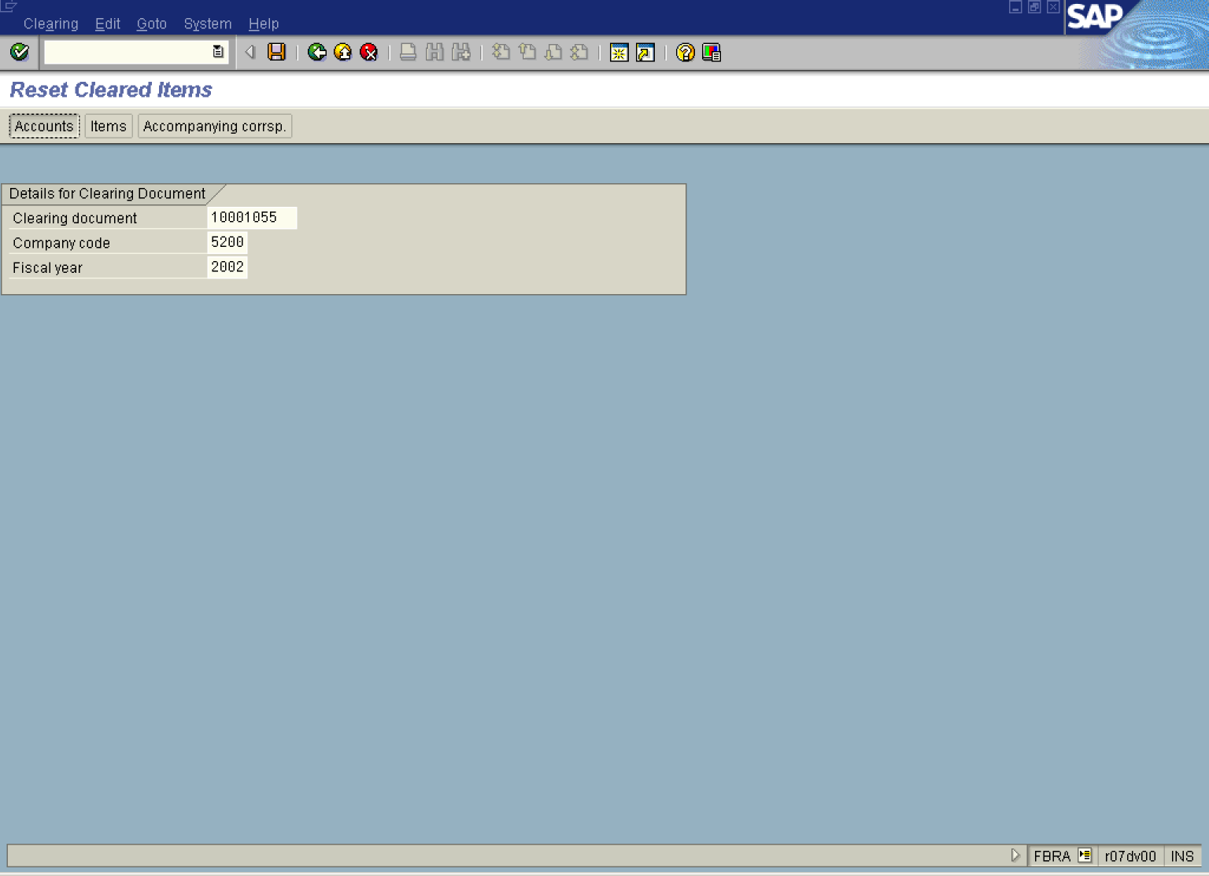

2. Update the following fields:

Field Name | Field Description | Values
Clearing document | Number of the document to be reset | Example: 10001055
Company code | Code identifying a separate legal entity for which a separate set of accounts is maintained for external reporting purposes | Example: 5200
Fiscal year | Fiscal year number | Example: 2002

Tip: If you don't know the clearing document number, open another SAP session, select transaction code FB03 (document display) and press List button to search for the required document. , double click on the required file and display the line item of the document you want to clear.

Display document: Line item

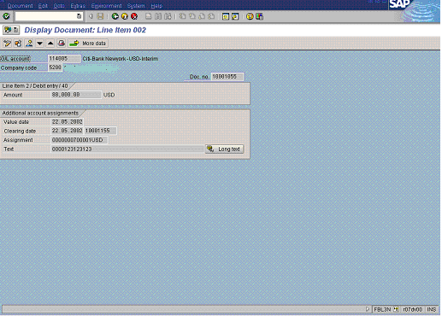

3. When you updated the required fields, click Enter Button to confirm your entries (only certain fields can be changed like assignment & text fields)
4. You can display some details regarding the clearing document before resetting it. Click e.g. Accounts Button . The system will display all the accounts involved in clearing operation:

Accounts Included in Clearing

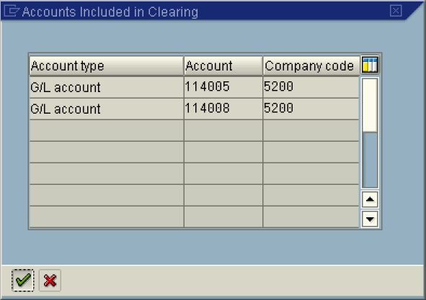

5. Click Enter Button to close this screen.

Reset Cleared Items

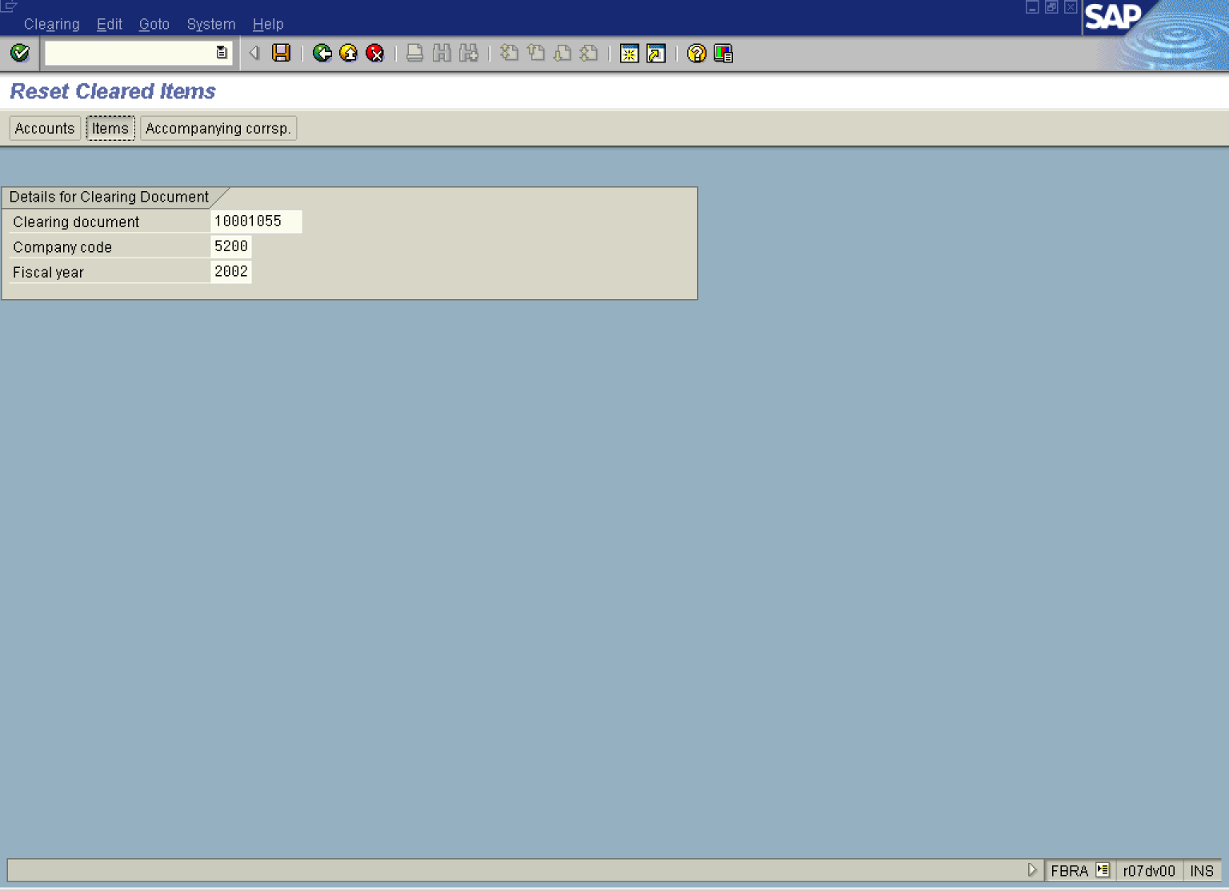

6. Click Items Button to display documents cleared by the clearing operation:

Reset cleared items

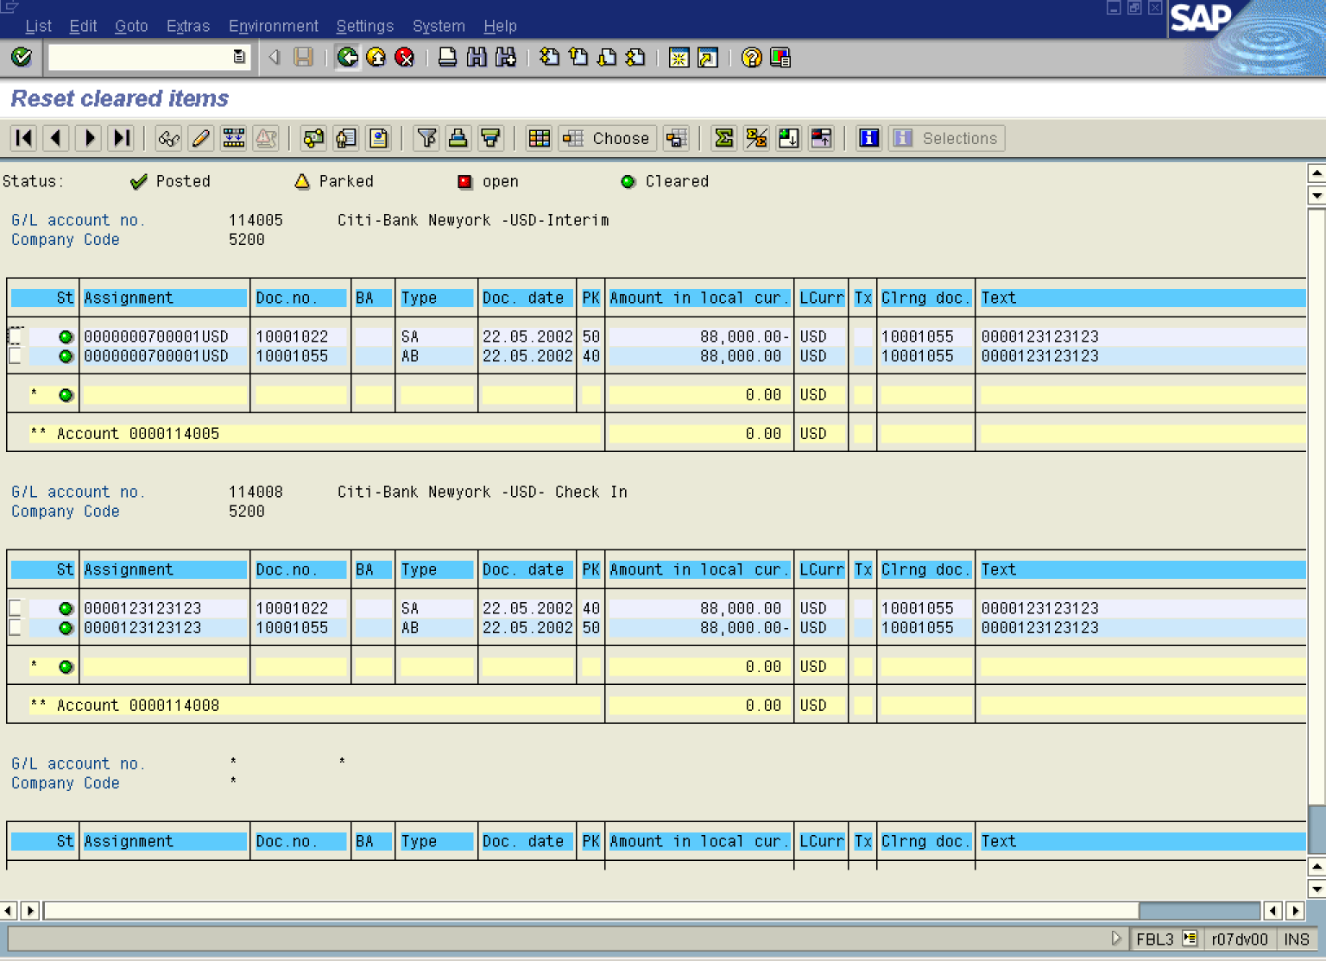

7. Click Back Button to close this screen:

Reset Cleared Items

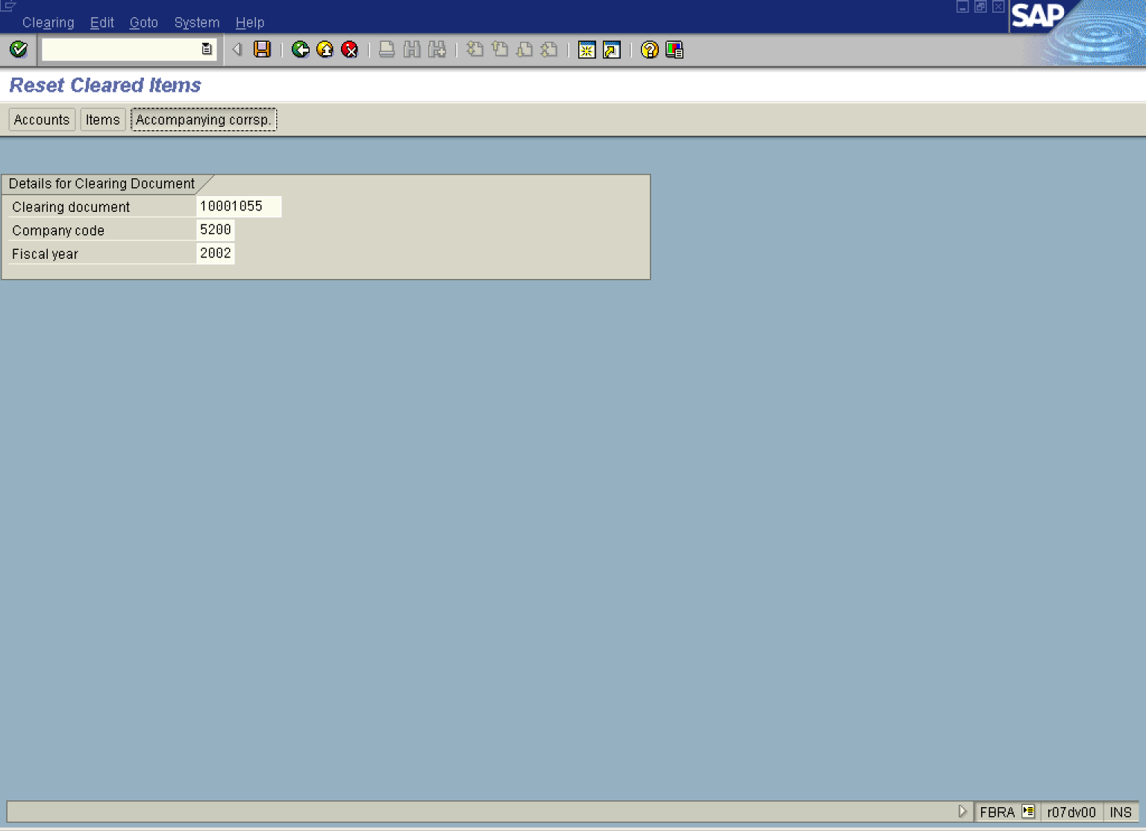

8. To reverse the clearing document click Save Button .

 This particular clearing document includes also another accounting document. Typical example of such document is posting an outgoing payment for vendor invoice. You post a bank document (real posting takes place) and at the same time system creates a separated clearing document. So, when you try to reset a clearing document, you can in the same transaction run post a reversal of outgoing payment document.

Reversal of clearing document

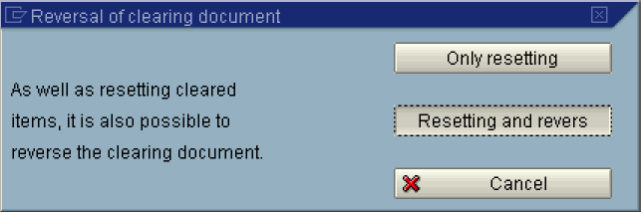

9. You can choose to only reset cleared items or reset items and reverse the accounting document that is connected with clearing operation. Click “Resetting and reverse” button:

Reversal Data

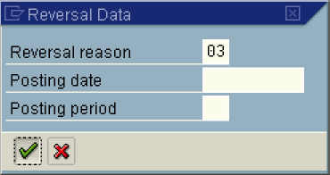

10. Update the following fields:

Field Name | Field Description | Values
Reversal reason | Enter type of reversal (e.g. negative posting in the same period as original document) | Example: 03

11. The message bar displays “Document XXXXXX was posted in company code 5200”. The system reset the cleared items and posted a reversal document.

